Statistical Learning

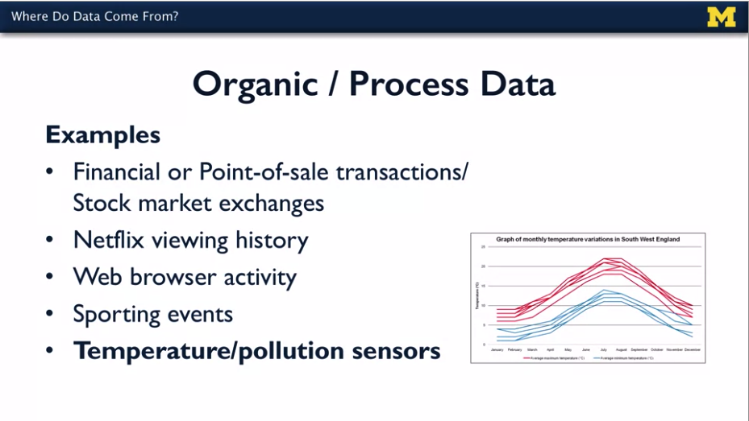

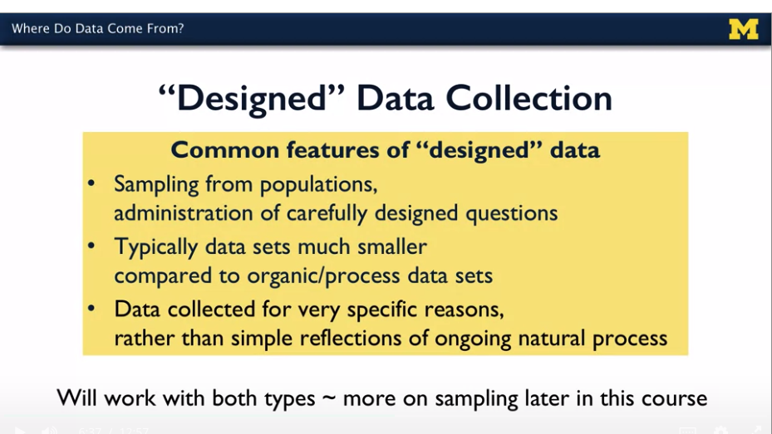

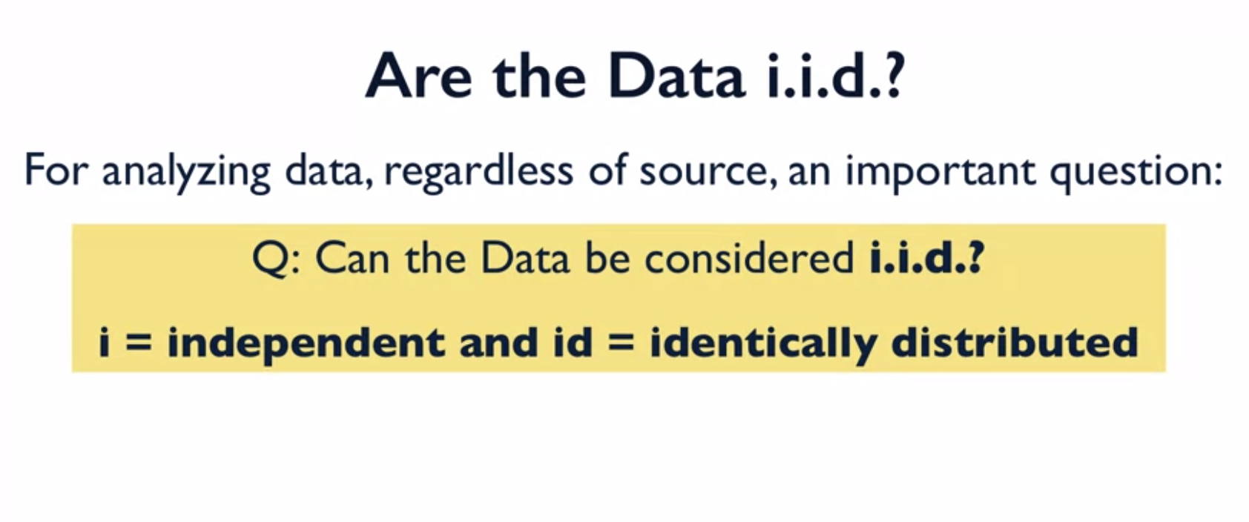

For analyzing data regardless of the source of the data, an important question that we need to ask is can the data be considered i.i.d? Now, the first i refers to independent and then the later i.d refers to identically distributed. So, i.i.d stands for independent and identically distributed data. So, what does that really mean? Observations on a variable of interest in the i.i.d case are completely independent of all observations. So, there's no correlation between the different measurements that are collected from different units in the population, different stock market exchanges, different baseball games, different individuals who are responding to a survey, all those observations are independent of all the other observations that might ultimately make up a data set. In addition, all of the values that we actually observe arise from some common statistical distribution, so that's the identically distributed part of i.i.d. So all the observations are independent of all the other observations and the values that we're looking at are all arising from some common statistical distribution, that's where the i.i.d terminology comes from.

Given these i.i.d data, we can estimate the features of that distribution, things like the mean exam score, the variance in the exam scores, extreme percentiles of the exam scores and then make inference about those features. What do we think the overall mean is in the population? Or what do we think the extreme percentiles are in some larger population of students that would take introduction to statistics at this university? In the i.i.d case, we can estimate the features of that distribution with a certain amount of precision so we can determine how much precision those different estimates have assuming that the data are i.i.d. So it's an important assumption that enables particular types of statistical procedures in describing data sets and describing populations. So, what do we do if the data are not i.i.d?

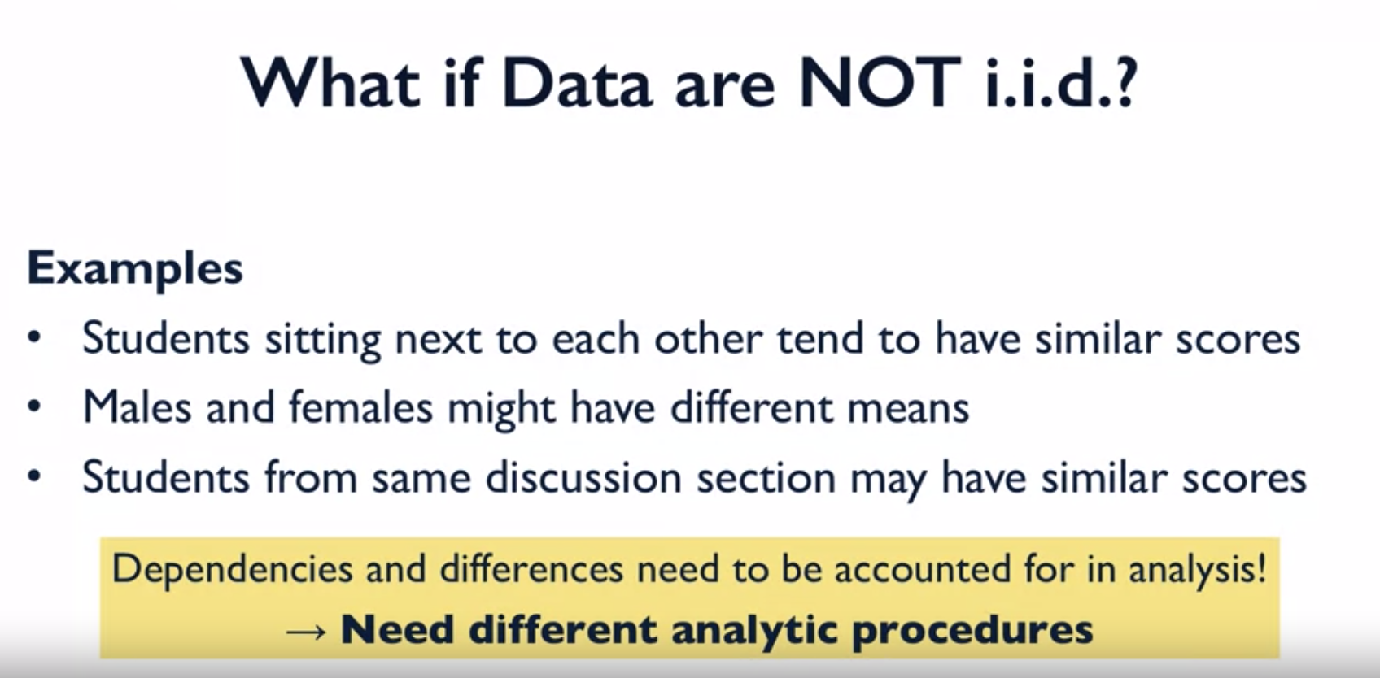

So when you think about it, this statistical procedures that we'll be talking about, they either assume that the data are i.i.d or they assume that the data are not i.i.d. So, we're going to be talking about these different analytic procedures in these different settings as we move forward in the specialization. But the key point up front is that understanding where the data come from is an **important piece of information for determining what analytic procedures to use.**

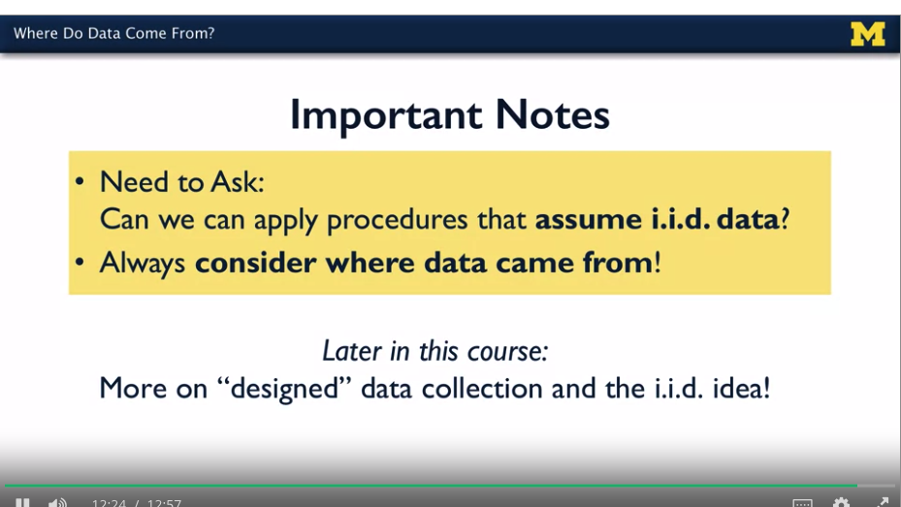

Variable Types:

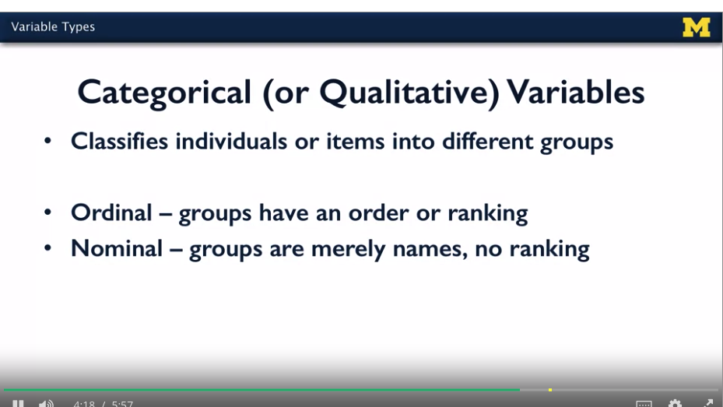

Study Design:

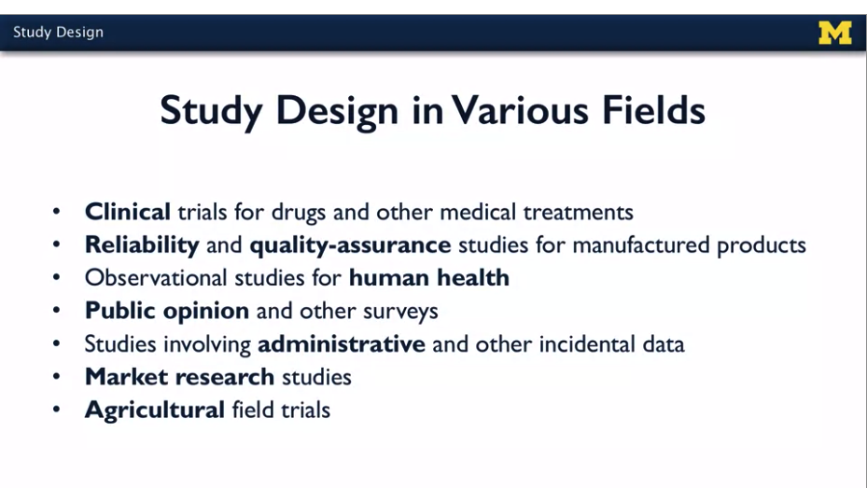

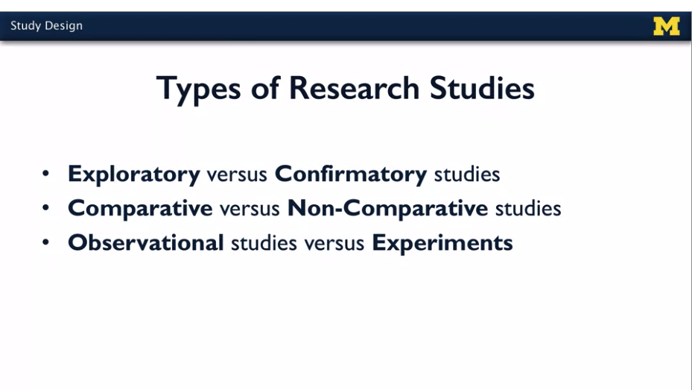

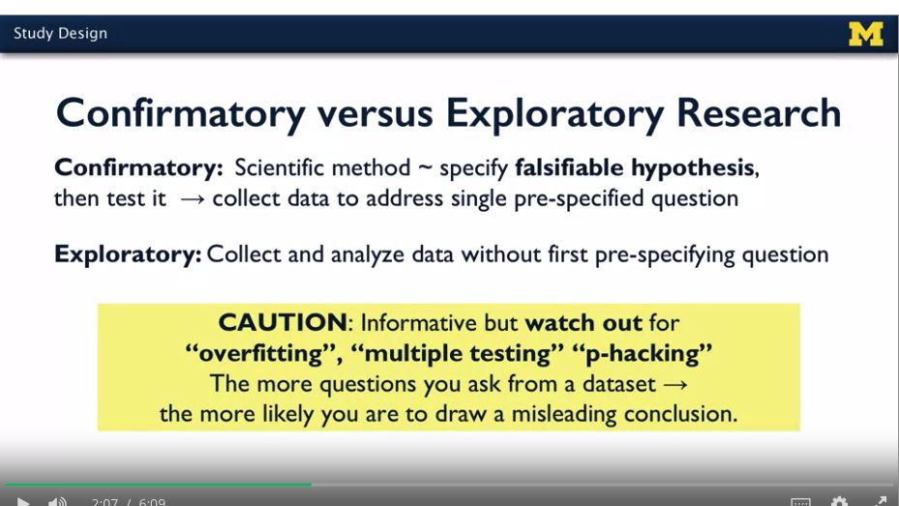

**Comparative and non-comparative:**

Many other research studies are compared to the nature, where the goal is to contrast one quantity to another. Let's take a look at a few examples. We can compare yields of oranges in plots of land that are treated with different fertilizers. We can compare the preference of voters for one candidate for office to another. We might want to compare the rates at which viewers will click on one of two different versions of an online ad.

In non-comparative research studies, the focus is now on estimating or predicting absolute quantities, not explicitly comparative.

Observational:

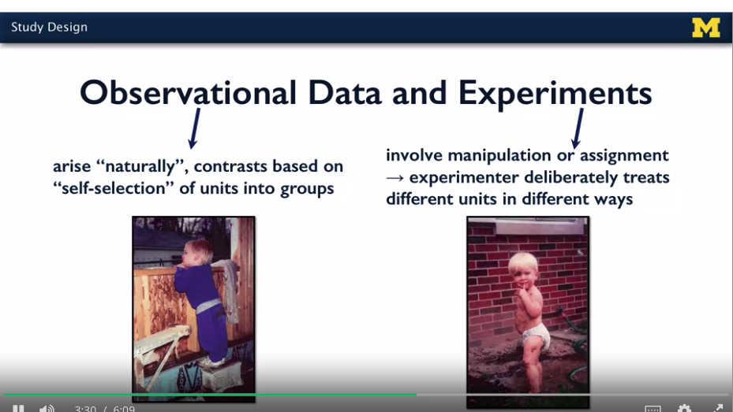

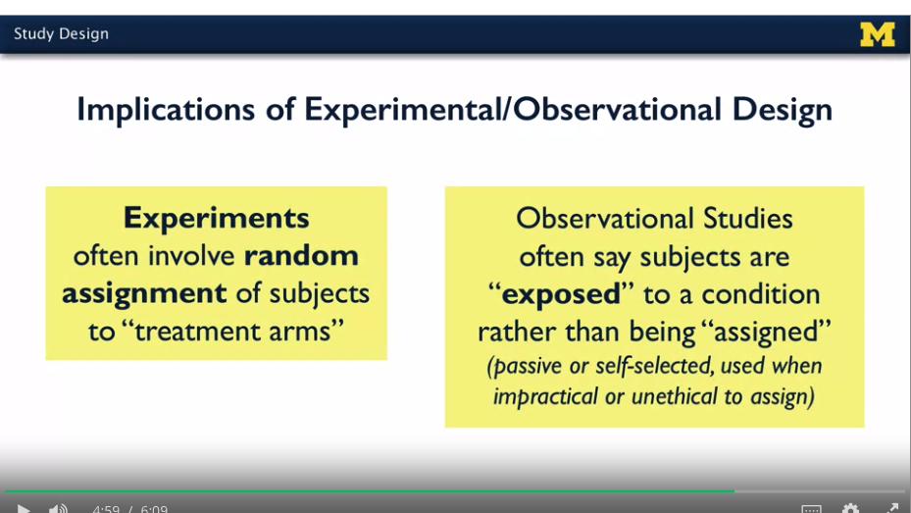

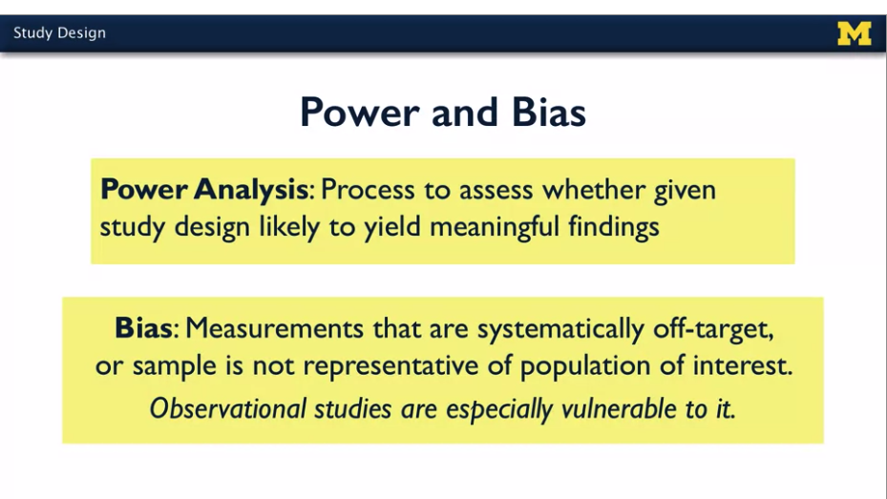

**Categorical Data:**

How to summarize and visualize?

Summarize.

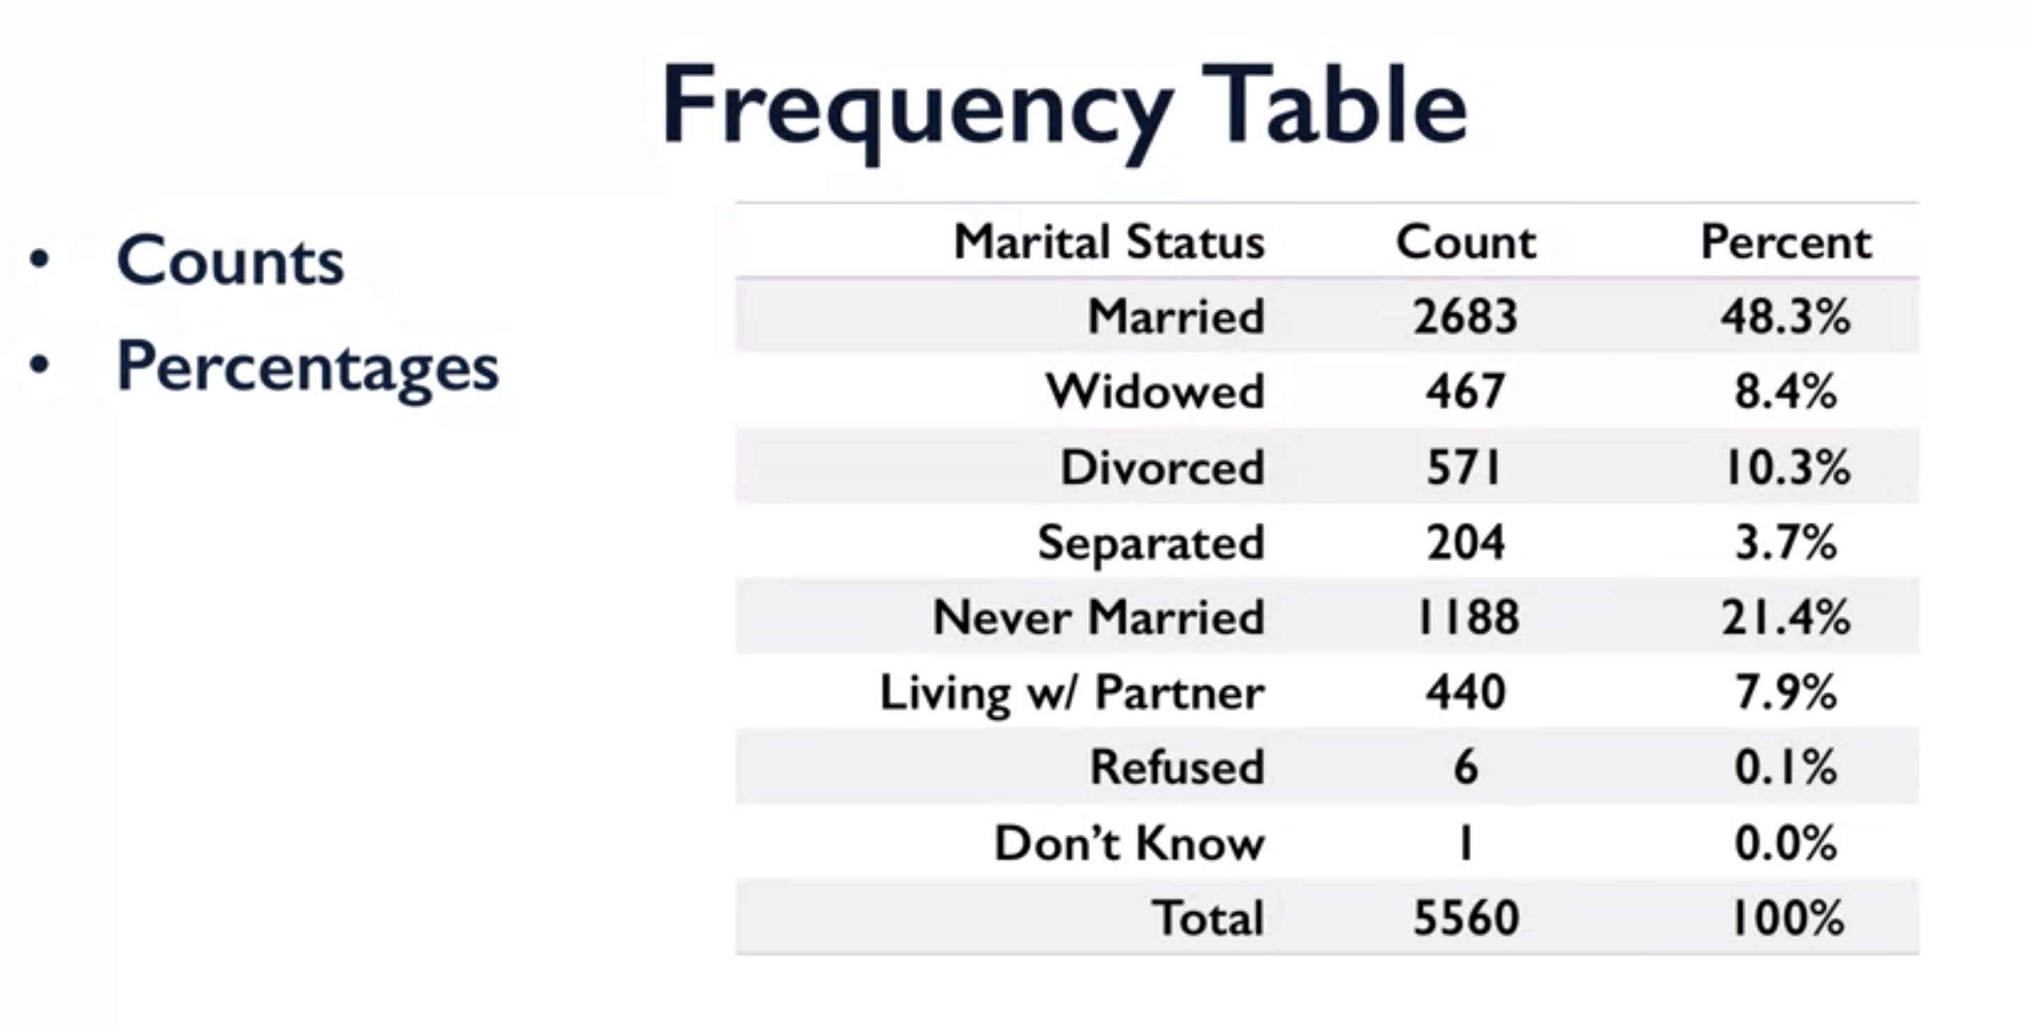

Visualize:

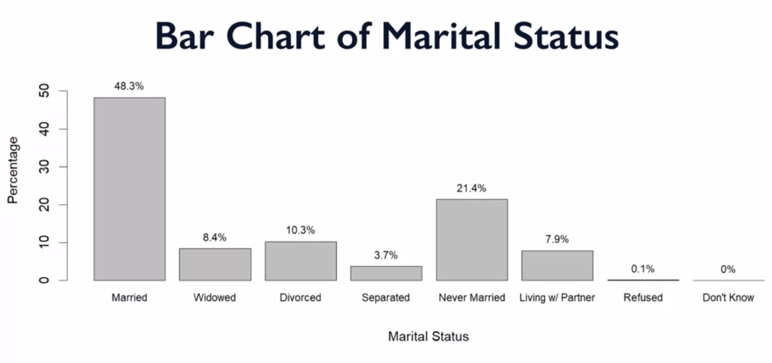

For nominal data, where the order doesn’t matter it would be good to sort the categories.

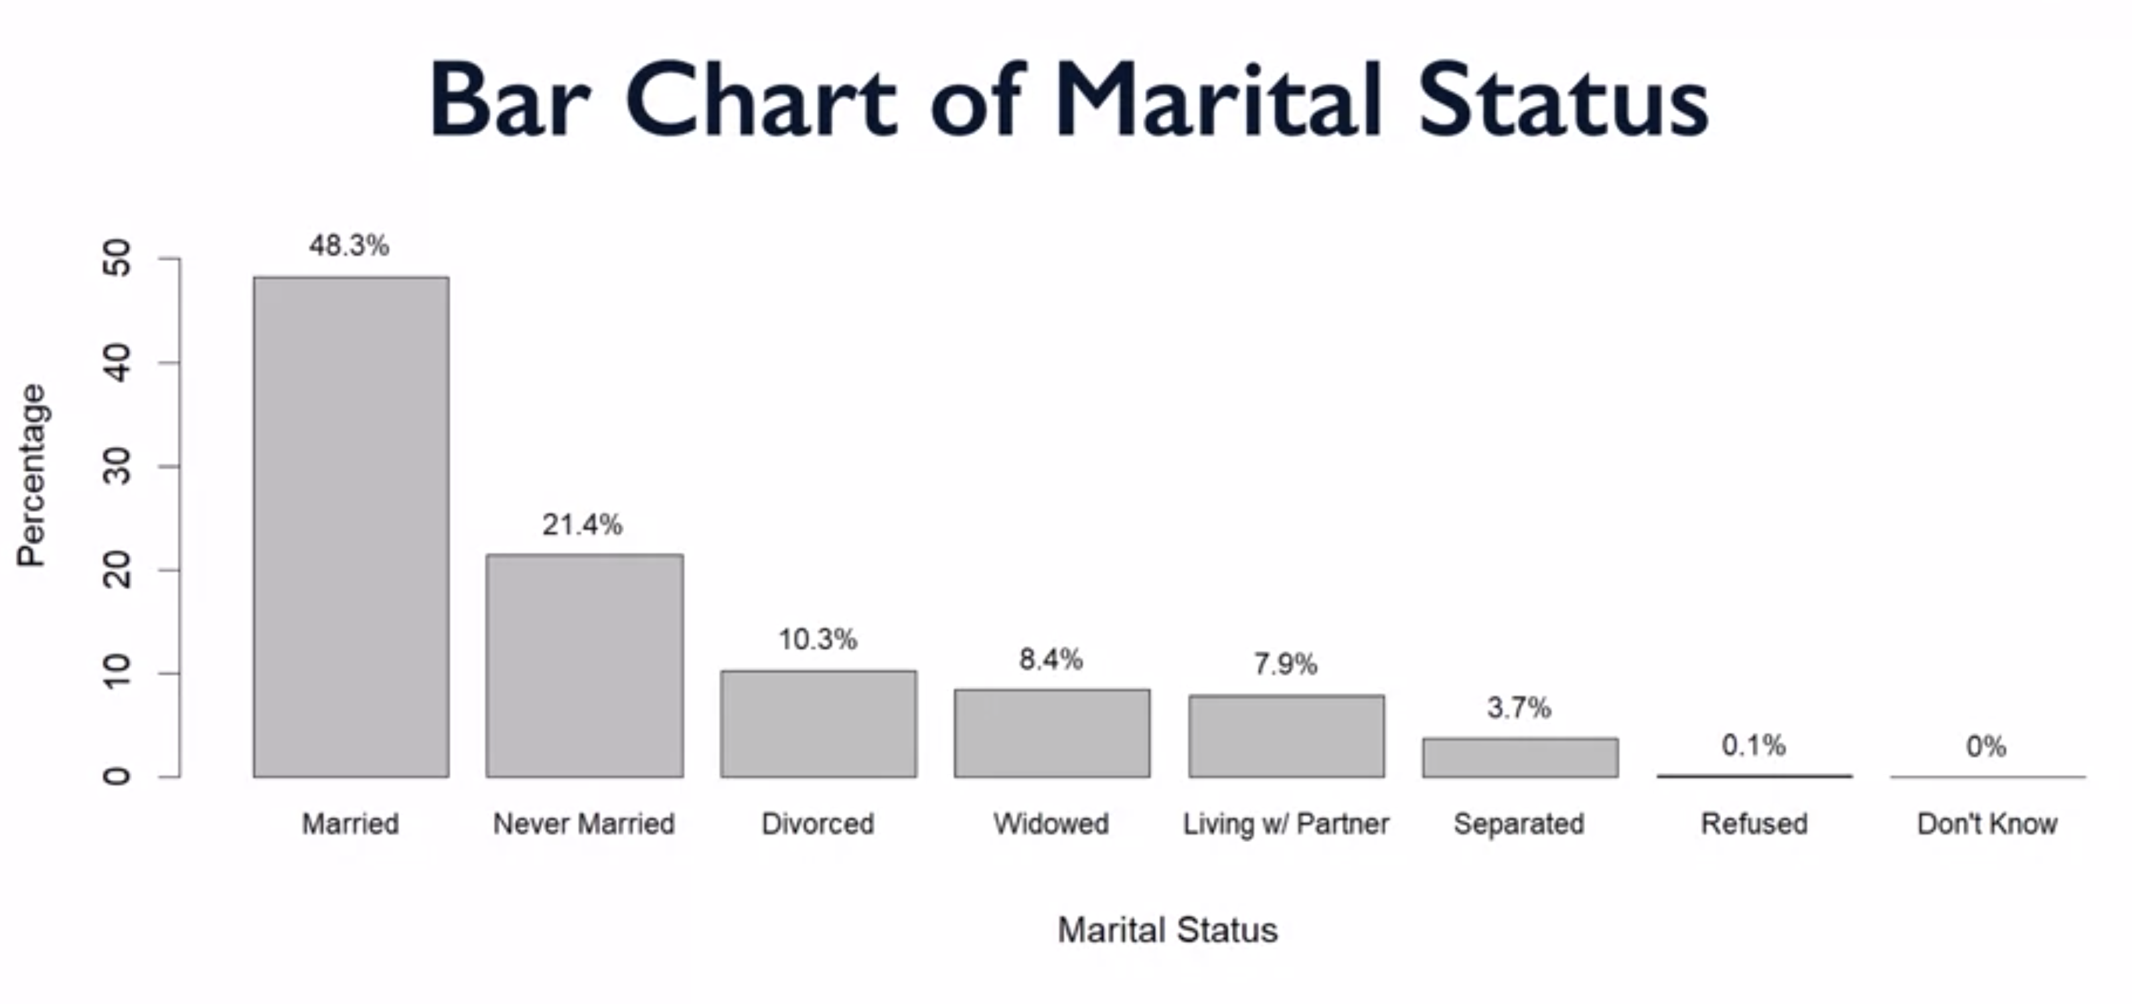

Other viz is pie charts – But we don’t recommend pie charts

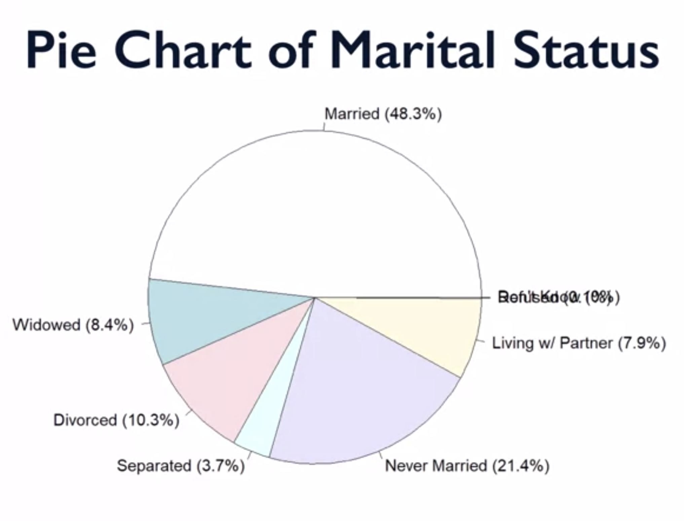

Overlap, visual

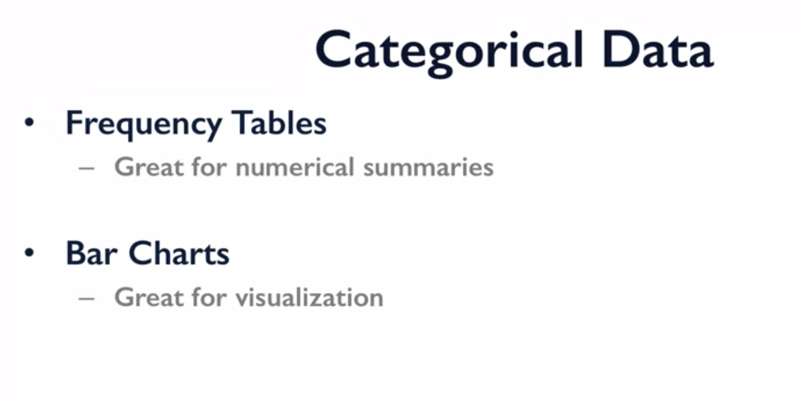

Quantitative data:

Histograms:

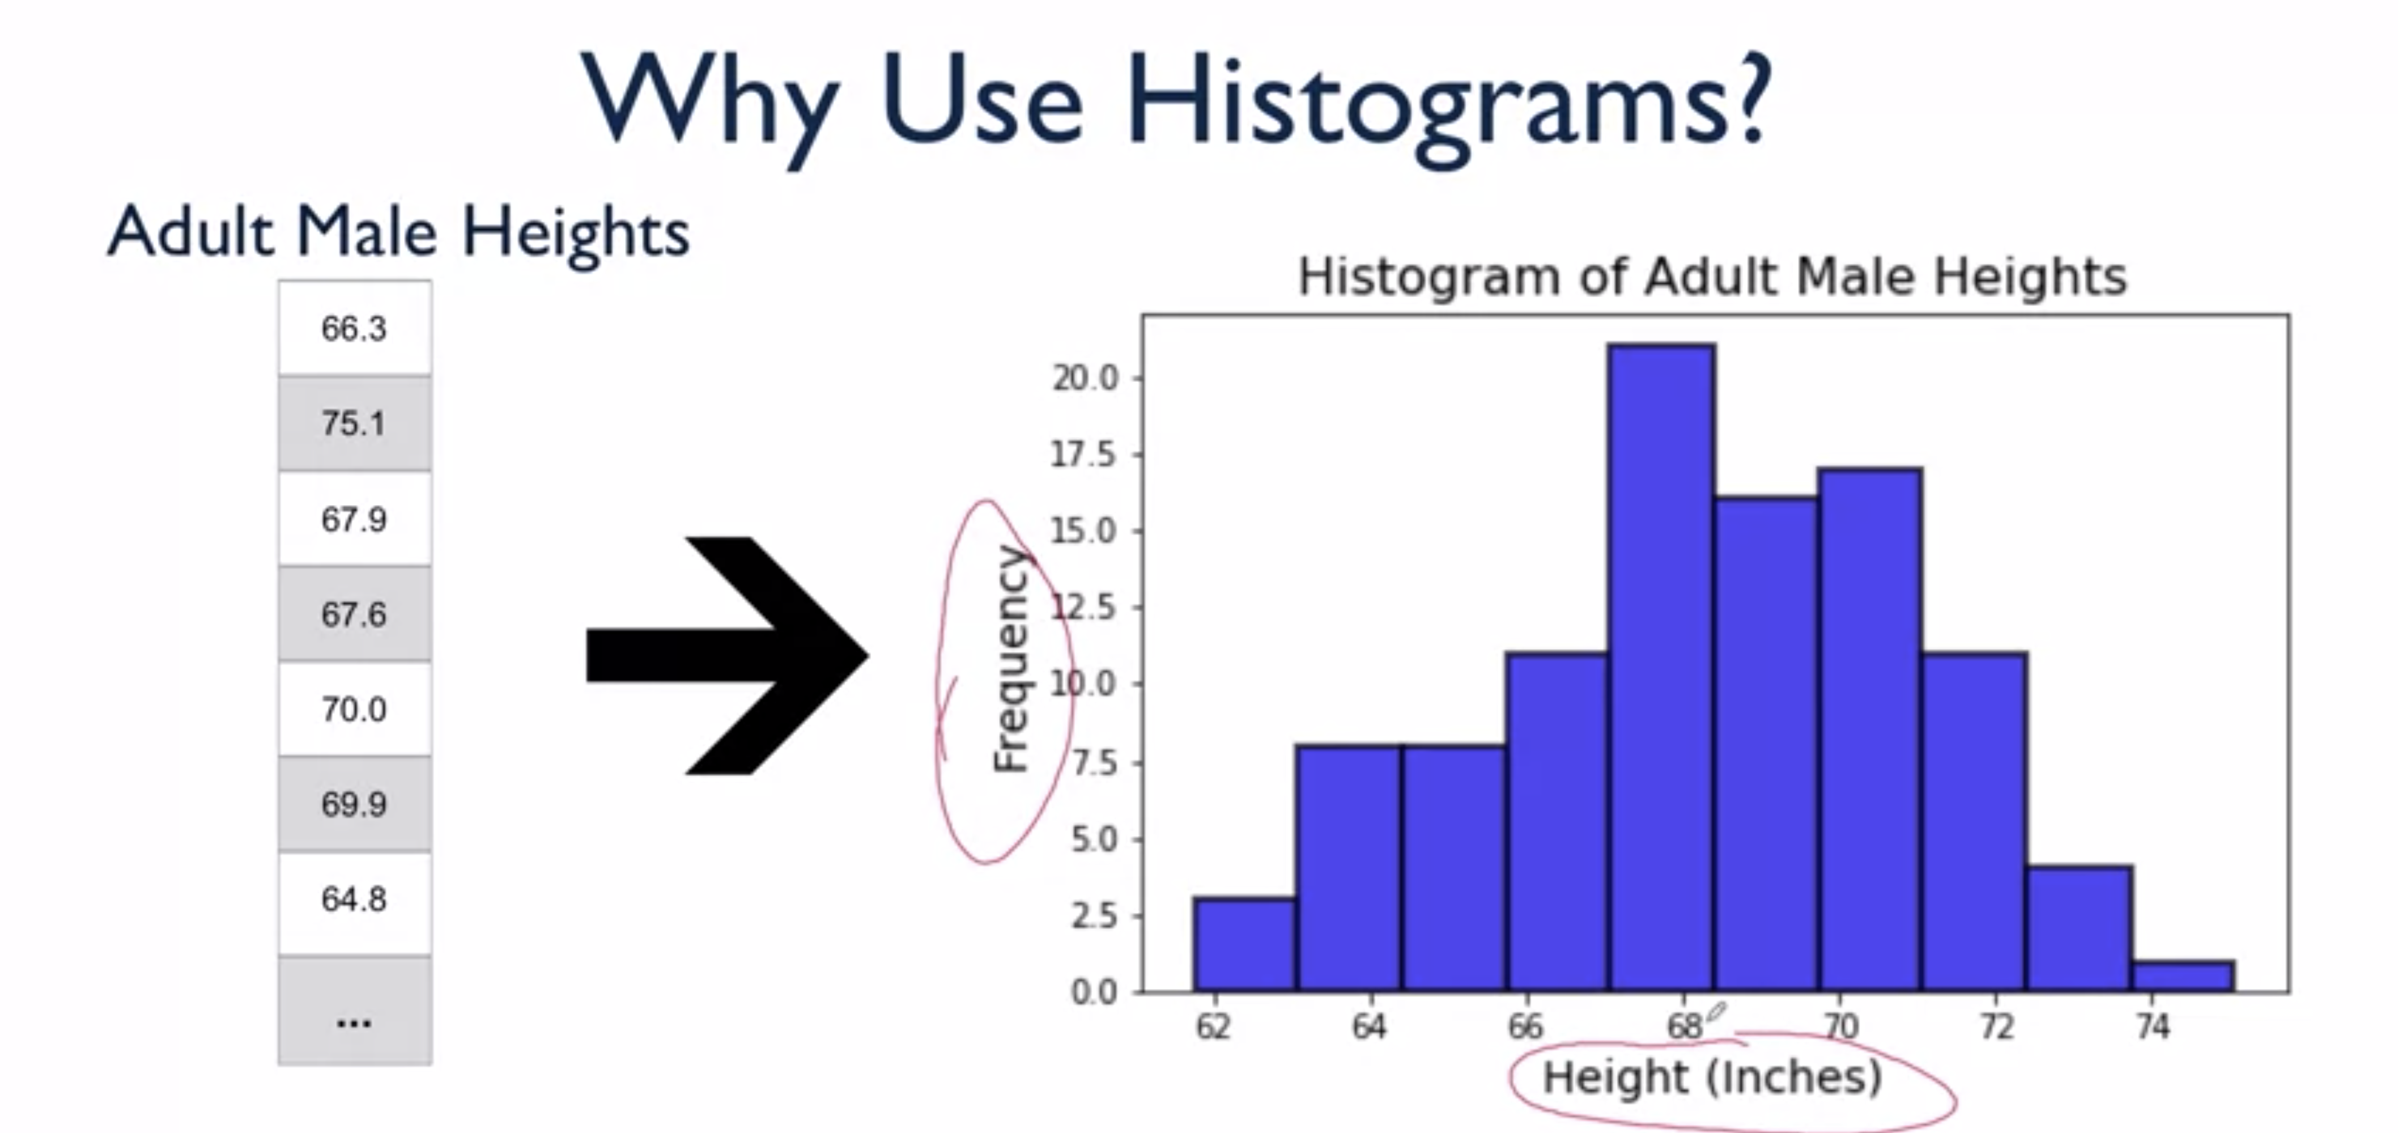

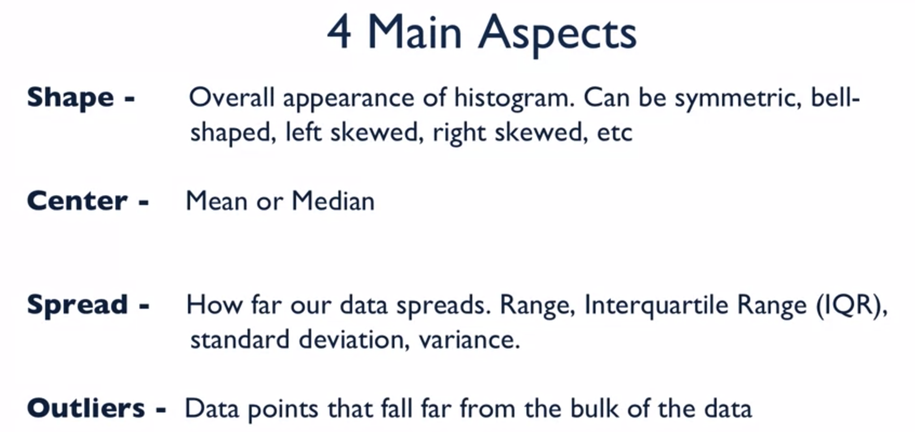

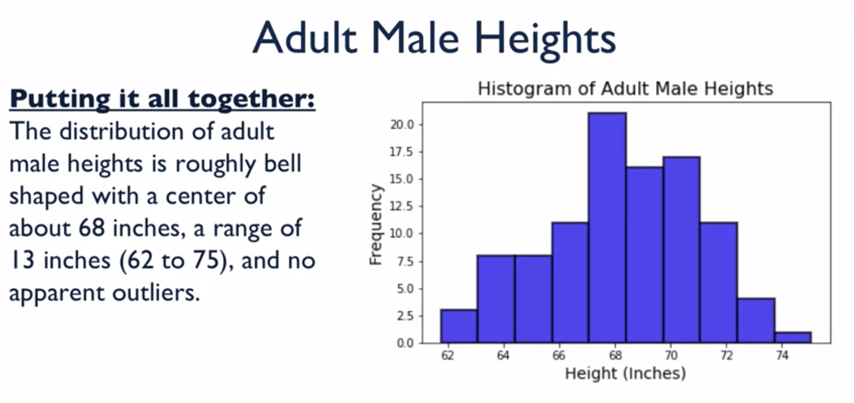

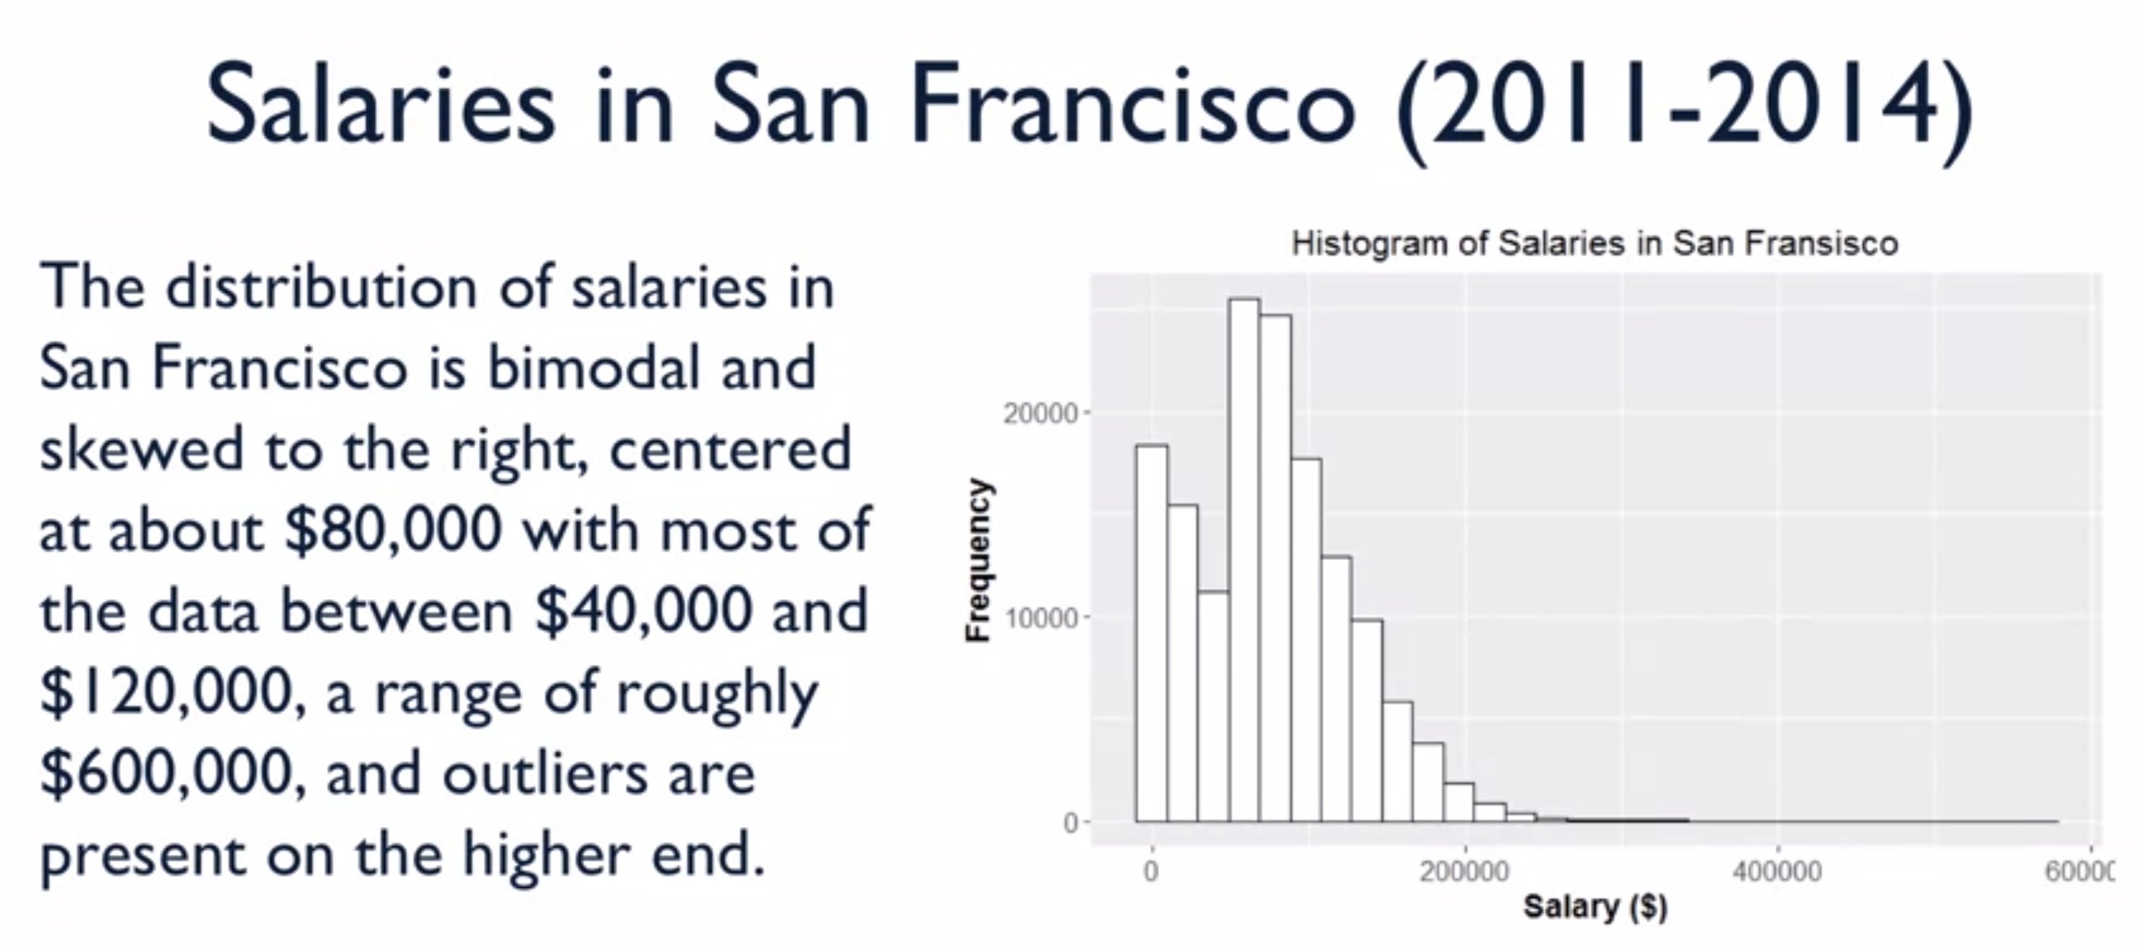

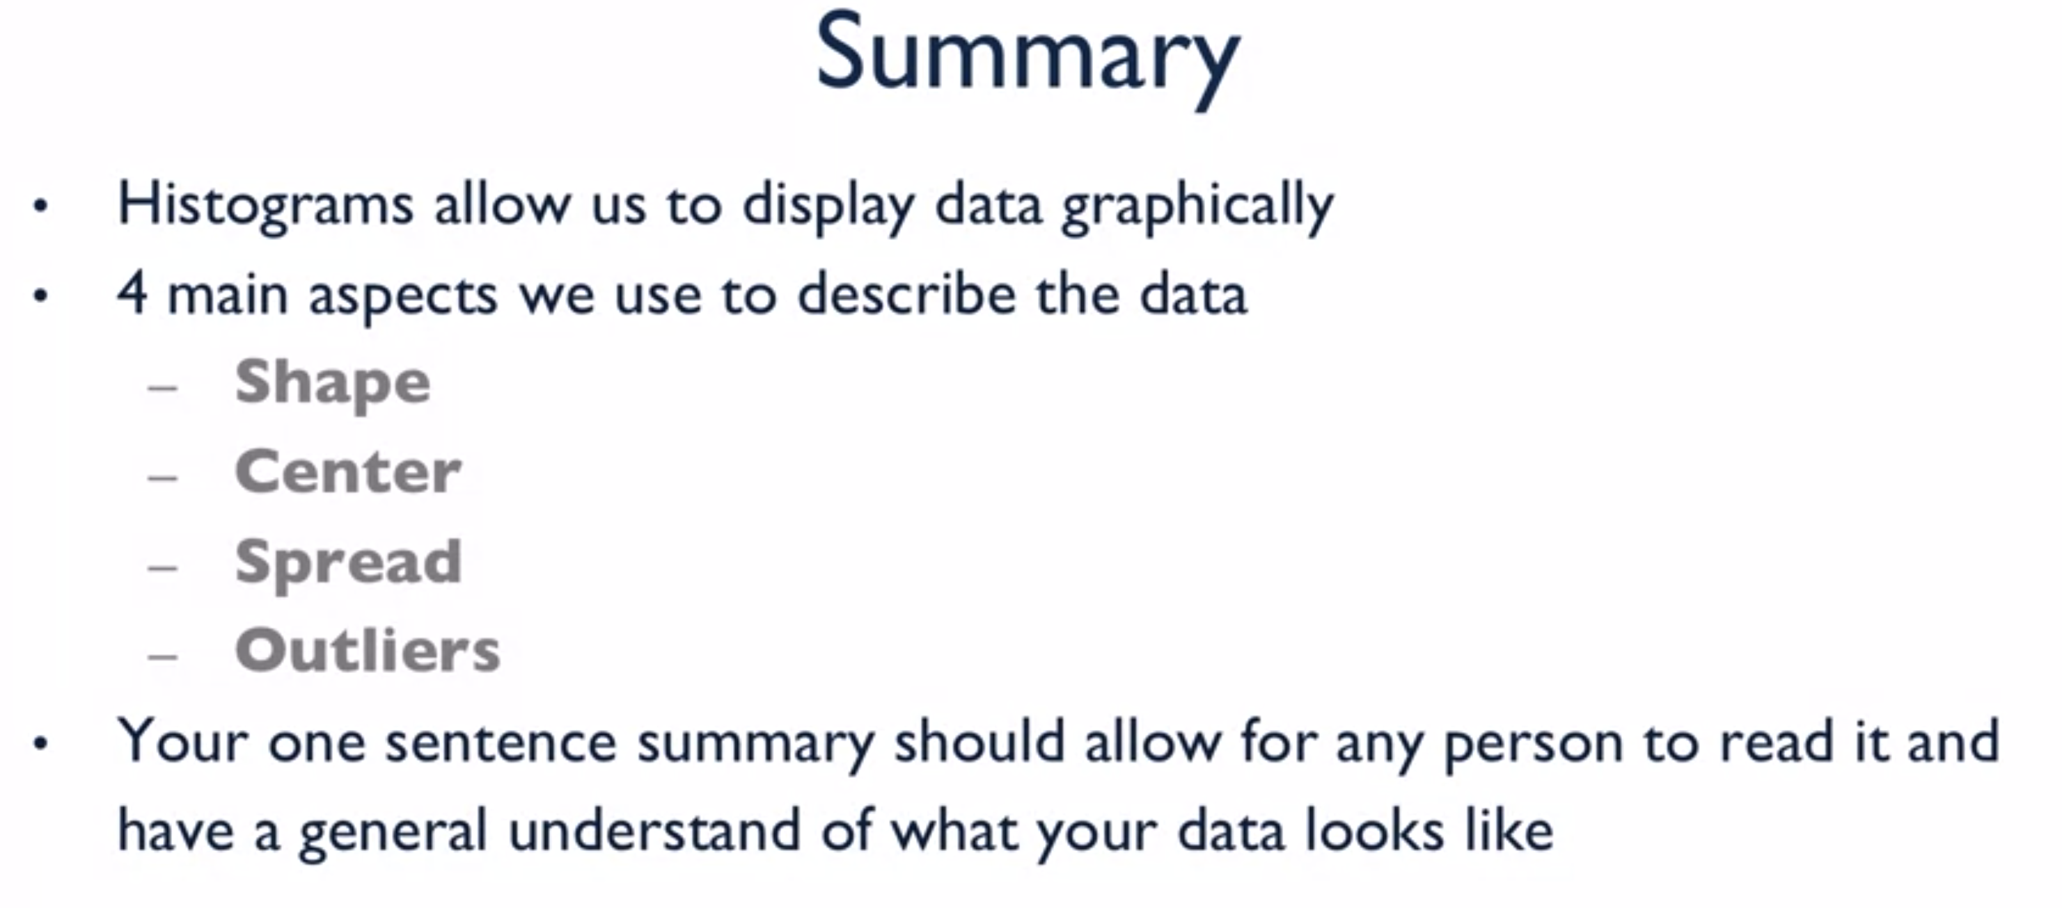

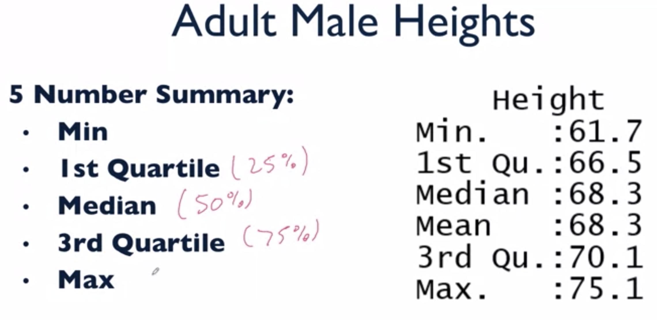

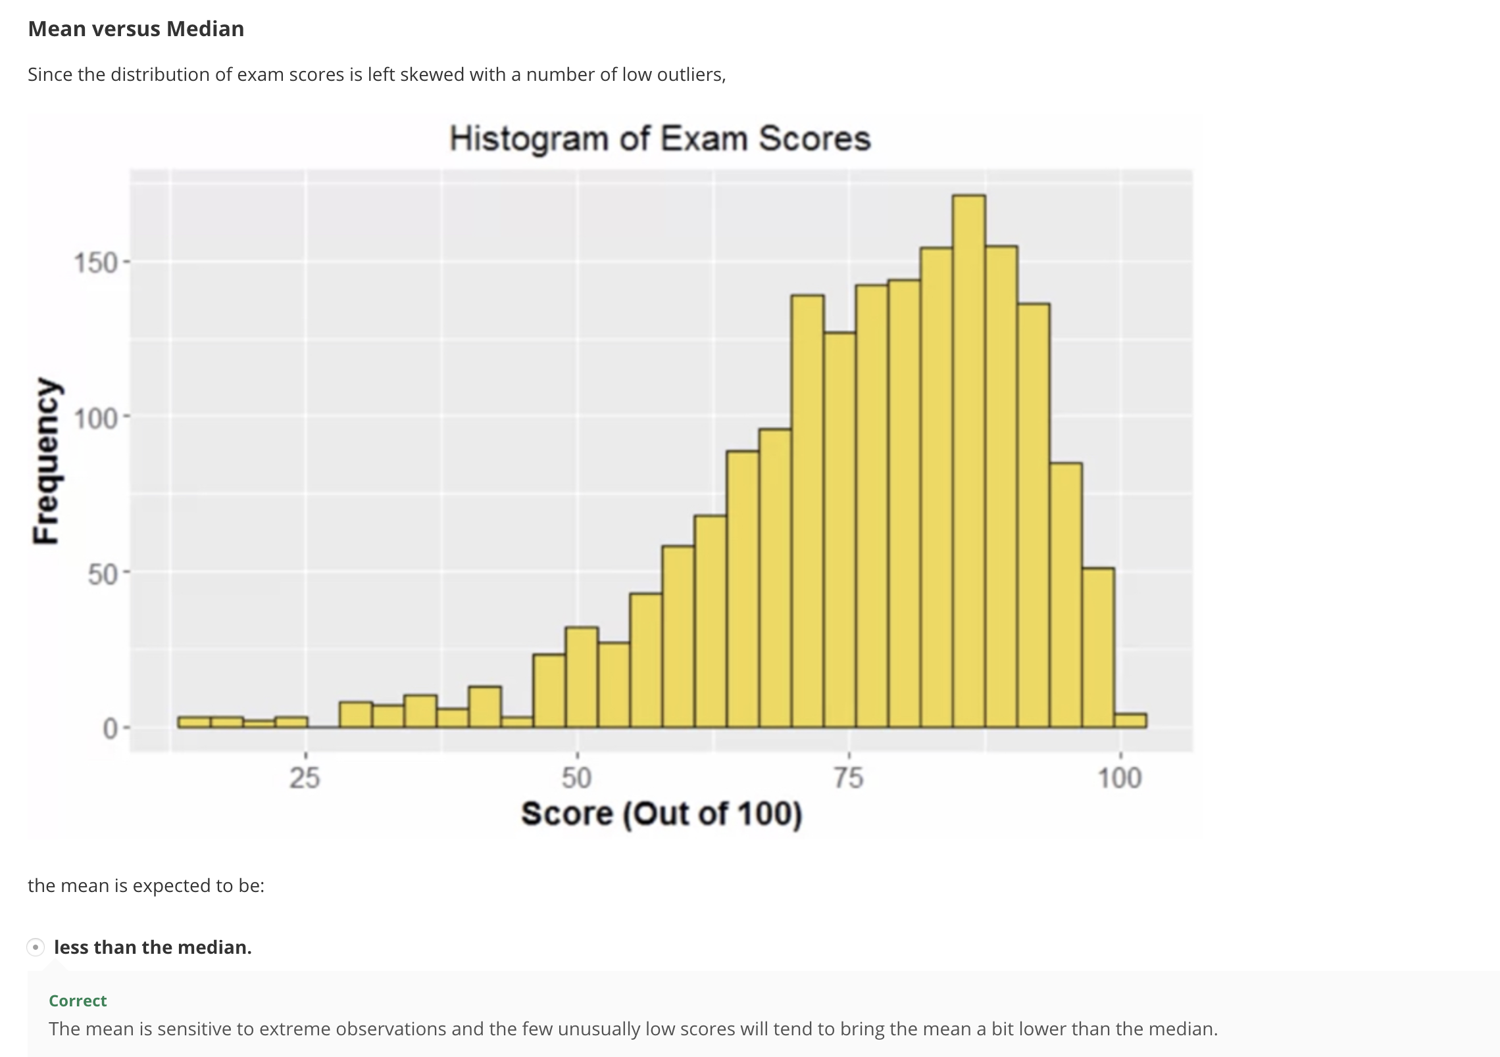

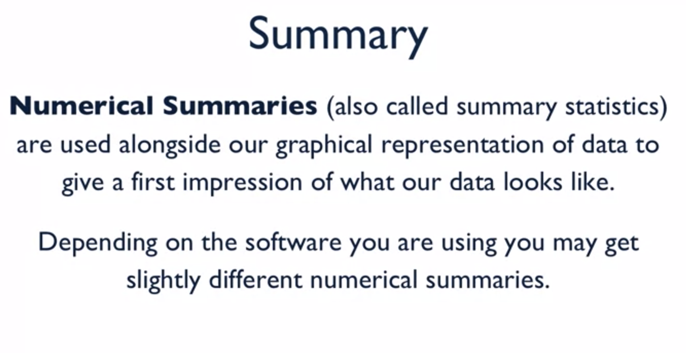

Standard Score:

Empirical Rule: 68 – 95 - 99.7

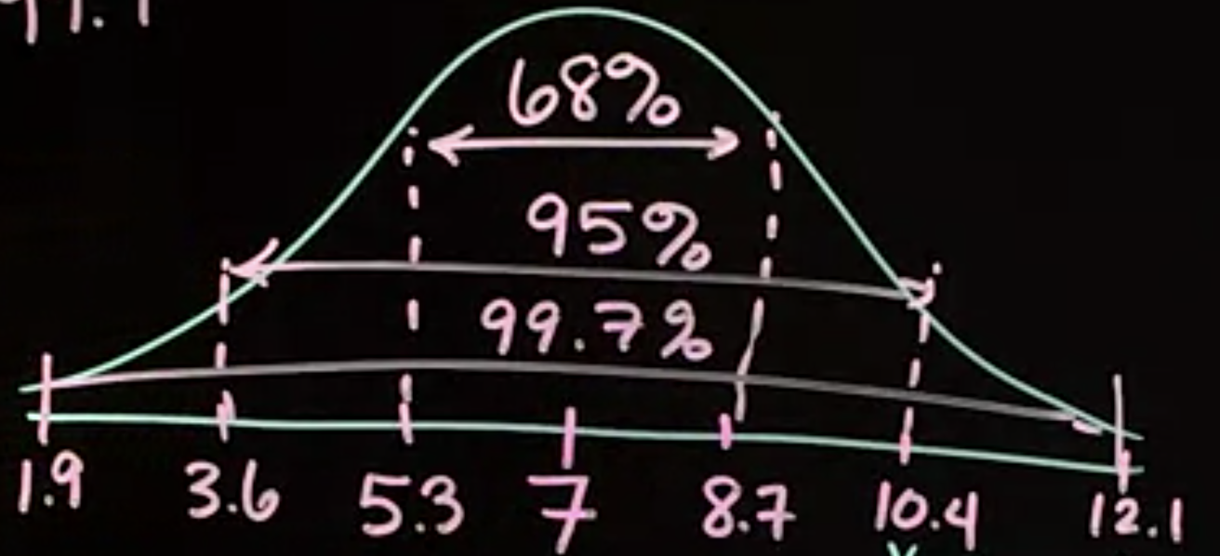

Z-Score:



Boxplots:

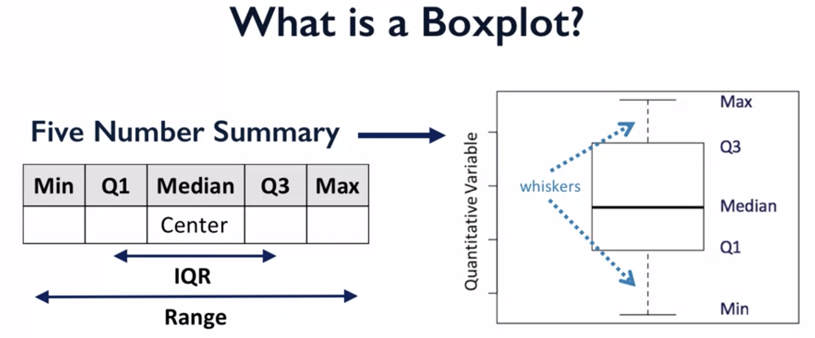

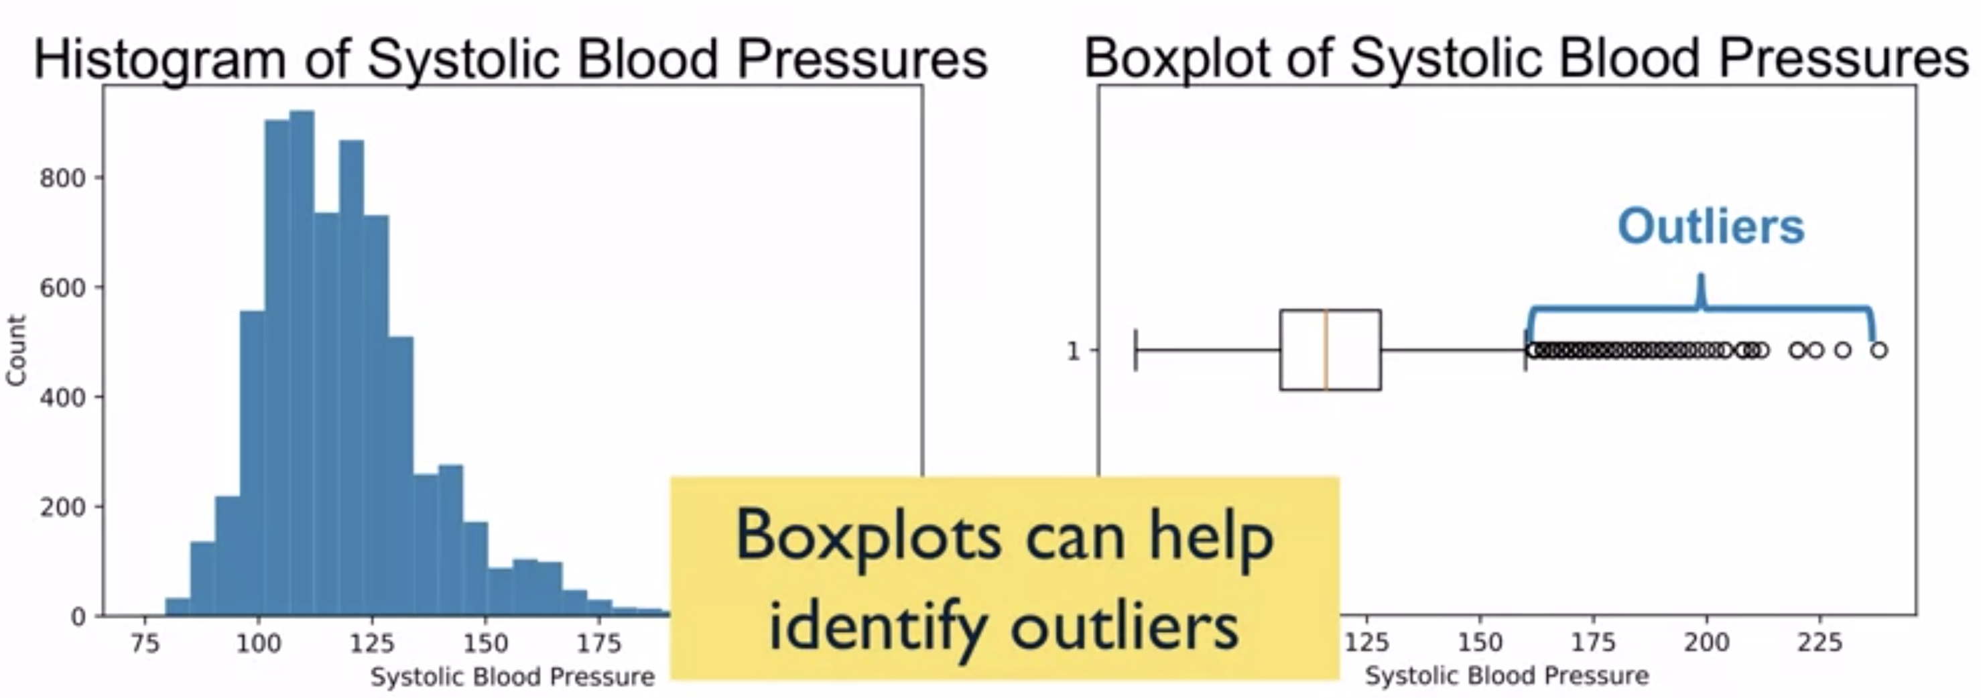

Some students who did well, some students who didn’t do well.

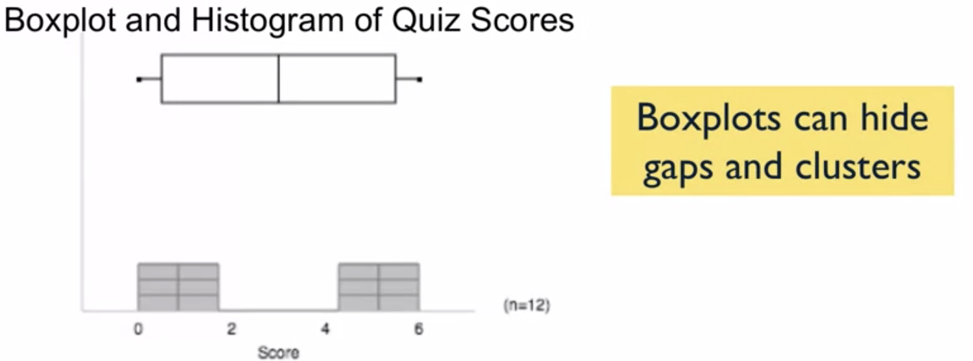

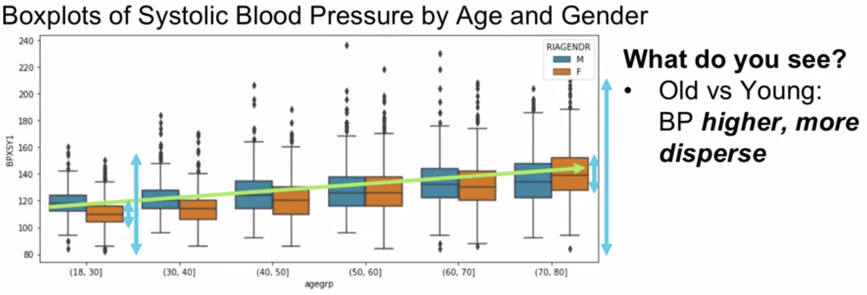

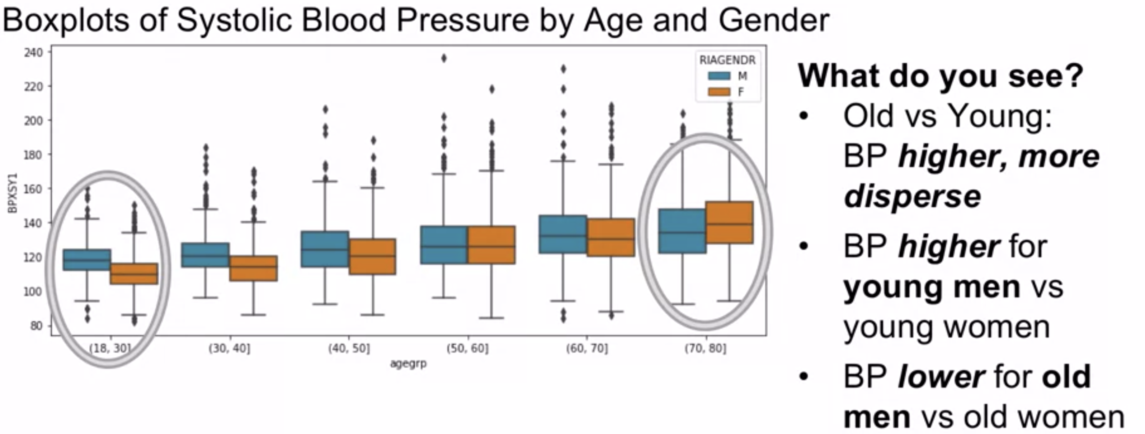

Boxplots are useful for comparing sets of observations.

Practice Quiz:

